**Good UI/UX**   
  
1. **Medium**

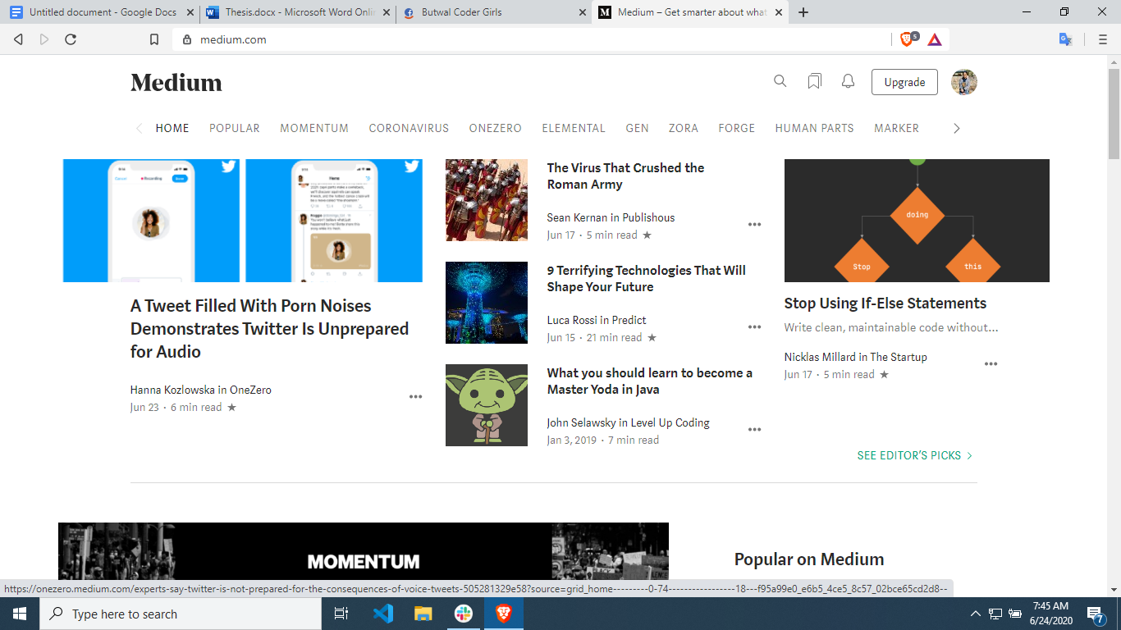

Medium is an online reading and publishing platform. I think it is just as gorgeous as it is functional. With minimal use of **color**, generous **line spacing**, and a well chosen combination of **typography**, this website gets everything right.

2. **Dropbox**

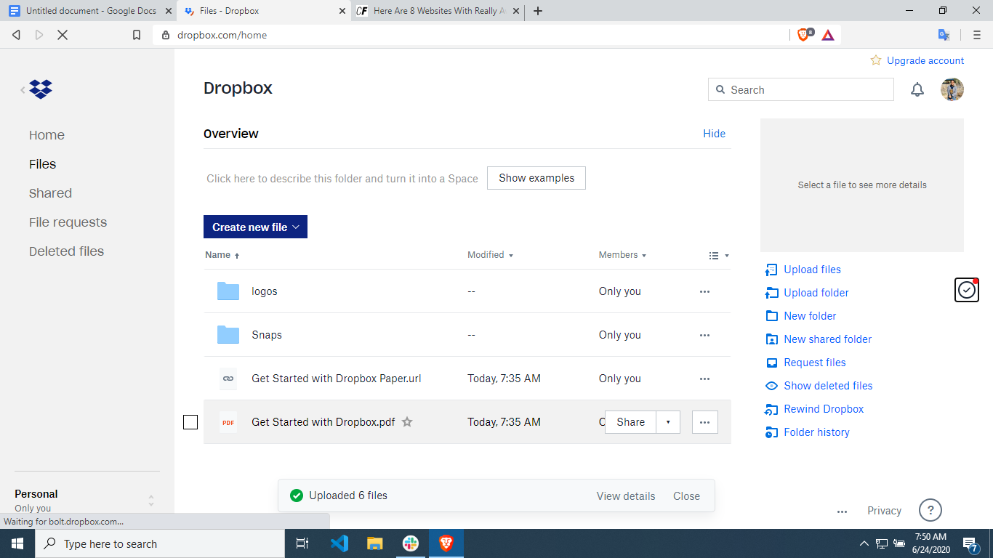

I think Dropbox has one of the most easily understandable interfaces by far. Having a folder and file organizational structure is easily recognizable to, you know, anyone who’s ever used a computer before.

There is **sequenced color palettes** and animated icons, and **wonderful illustration** that is coordinated with all the other wonderful illustrations – it manages to come across as experimental, creative and consistent.

**BAD UI/UX**

1. **1800 Flowers**[**https://www.1800flowers.com/**](https://www.1800flowers.com/)

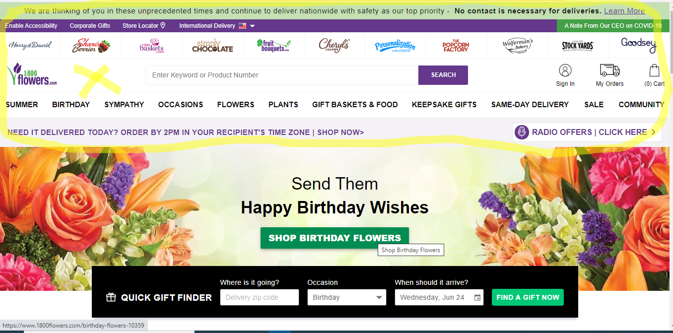

The website seems a stress for eyes while browsing its features.

No proper spaces

Hilarious color combinations

Doesn’t seem like a professional website.

1. Lings Cars

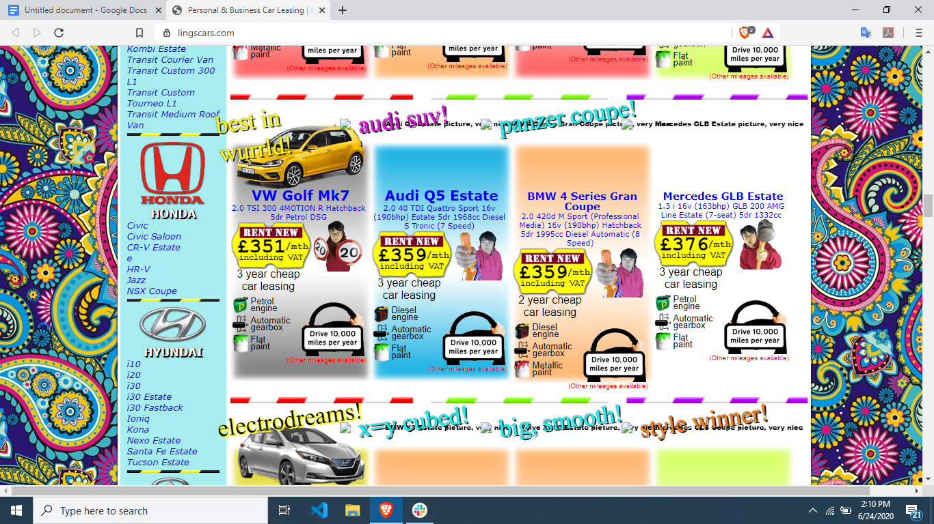

The web design is too hilarious to buy a car. It seems like a junk of ideas that cannot be easily focused while looking into it. The complexity and non-seriousness makes it a bad ecommerce website with a poorly constructed web design.  
  
No proper spacing,